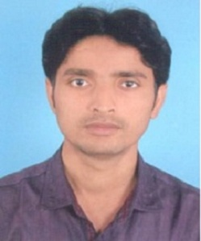
CURRICULUM-VIATAE

Amit Kumar Kashyap
98/360/410, Mohatsimganj,
Allahabad-211003
Contact No. 9453811812, 7905765387
Email :- 5626amit@gmail.com

CAREER OBJECTIVE:
A challenging growth oriented in a progressive organization where my ability, analytical & managerial skills are effective utilized to improve and contribution to organizational success.

ACADEMIC QUALIFICATION:
Master of Business Administration from Punjab Technical University (2013)
Master of Commerce from V.B.S. Purvanchal’ University Jaunpur (2010)
Bachelor of Commerce from V.B.S. Purvanchal’ University Jaunpur (2008)
Intermediate (Commerce) from U.P. Board (2005)
High School (Commerce) from U.P. Board (2003)

COMPUTER SKILL:
Desk Top Publisher : MS-Word, Paint, Power Point, Excel & Internet
Course of computer concept (CCC)
Typing : Typing in Hindi & English

WORK EXPERINACE:
Company : Bharat Sanchar Nigam Limited, Mirzapur (UP)
Designation : Office Assistance (Administration section )
Nature of work : File preparation, HR module, ERP, RTI, MIS,
Data feeding work, SIM activation, CAF entry
and monthly report etc.
Duration : January 2011 to January 2017
Company : Srinivasa Ramanujan Public School, 31 MG
Marg, Civil Lines Allahabad
Nature of work : ERP work (Student registration and admission,
Online fee feeding) Exam paper typing.
Duration : Jan. 2018 to till date

BEHAVIOR
CHARACTERISTICS : Commitment to quality and result
Responsibility
Sincere in attitude
Presentation & Leadership skills
PERSONAL DETAILS:
Father’s Name : Lt. Ram Gopal Kashyap
Date of Birth : 12 July 1987
Nationality : Indian
Religion : Hindu
Caste : OBC
Marital status : Married
Hobbies : Watching TV, Movies & Making Art
REFERENCE:
I declare that the above information is best of my knowledge and belief all particulars I have given are complete and true. I understand that any false declaration of misleading statement of any significant omission may disqualify me from employment and render me liable to dismissal if I am offered employment.

(Signature)
Date: 27-05-19
Amit Kumar Kashyap

