ELVIS JOSEPH ALBERT

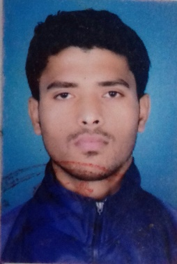
63h/37 Sona vihar colony near IPEM international college, Allahabad
Ph no.: 9818491779
E-mail: elvisalbert21@gmail.com
________________________________________________________

Objective

Would like to be a part of a growth oriented, dynamic, organization that provides substantial opportunities for professional & personal growth

Education

Examination  (Name of institution) | Specialization | Year of passing | Percentage Secured
Bachelor of Arts from  Allahabad University | B.A (Pass) | 2019
Govt. boys senior secondary school, Dhaka, New Delhi 110009 | 10+2 | 2009 | 2nd Division

Work Experience

- worked in Boys’ high school & college, Allahabad for 4 year (30th march 2013 till 30 march 2017)
- one year working experience in REEBOK ( under franchise)
- Worked with SSIPL PVT LTD Company (NIKE). (2009-2012)

Work Profile/ Responsibilities

- Worked as a PTI in Boys’ High School & College, Allahabad.
- Worked as a senior executive in Reebok for one year
- Worked as executive in NIKE( Ssipl pvt ltd company)

Special Skills

- Written and verbal command over English & Hindi Good communication.
- Basic knowledge of Microsoft Office (MS Word, MS Excel, MS PowerPoint)
- setting exemplary performance for team/individual motivation

Hobbies

Listening to music, surfing web, shopping

Personal Details

- Name Elvis Joseph Albert
- Father’s Name Raymond Albert
- Date of Birth 21st April 1989
- Language known English & Hindi
- Marital status married

